5.7 Divergence Theorem

In this section we introduce a new idea related to vector fields and a related application.

Definition: If is a vector field on and , , and exist, then the divergence of F is the function of three variables defined by .
Symbolically one may write .

Remark: To help ourselves in remembering the formula for divergence, we introduce the differential operator (“del”): . Then, we can think of the divergence of F in the following way: .

Example 1: Consider the vector field . Find .

By definition we have that .

Application: In the context of fluid flow, if F is the velocity of a fluid, then represents the net rate of change (with respect to time) of the mass of fluid flowing from a point per unit volume. In other words, is the extent to which there is more exiting an infinitesimal region of space than entering it.

Therefore, if we at a point we call that point a source.
if we at a point we call that point a sink.
if we at a point it contributes to no change in the rate of the fluid flow.

Example 2: Let . Determine which points are considered sources, sinks, and neither.
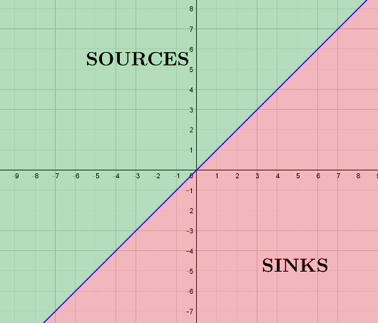

We calculate that .

Note that:
- if
- if
- if

We see that the coordinate z has no impact on the divergence here and therefore we will categorize all points in the xy-plane (points above and below these will have the same label). We identify to which group each point belongs in the picture above (points on the line are neither sinks nor sources).

Recall:
Green’s Theorem relates the line integral of a vector field over a closed curve in 2-D to a double integral taken over the region enclosed by the curve. There are two natural ways one might try to generalize Green’s Theorem which we now state.

- We might try to increase the “dimensions of the integrals” in Green’s Theorem by one. More precisely, we might guess that the flux of a vector field through a closed surface is equal to a triple integral taken over the region enclosed by the surface.

- Alternatively, if we have a closed curve in 3-space (rather than 2-space), we might guess that the line integral of a vector field over the curve is equal to a surface integral taken over the region that the curve encloses.

The first idea for a generalization of Green’s Theorem leads to the Divergence Theorem which is the focus of this section, and the second idea for a generalization of Green’s Theorem leads to Stokes’ Theorem which is covered in section 5.8.

So, in this section, we are interested in asking;
Does equal a triple integral under appropriate conditions?

With this question in mind, suppose that D is a region in the plane bounded by C and such that D, C, and F satisfy the hypotheses of Green’s Theorem.

We ask: What (if anything) does Green’s Theorem say about where n is a unit normal vector to C pointing away from D.
To answer this question, suppose that C is given by where . Then the unit tangent vector to C at t is . From this it is fairly easy to see that: .

So, we have that

Then, by Green’s Theorem, we have
.

So, , and it is now natural to state the divergence theorem.

Note: Although we will not prove it here, it may seem plausible that this idea may again extend to integrals “one-dimension” higher. This extended case is called the Divergence Theorem.

Theorem (The Divergence Theorem):
Let G be a solid whose surface is oriented outward. If F is a vector field whose component functions have continuous partial derivatives on an open region that contains G, and if n is the outward unit normal on , then
.

Note: Recall that positive orientation of a solid is outward.
Note: If has inward orientation then it would be the case that .
Proof: See pages 1149-1151 for an outline of the proof. We will not go over the proof in class since it is a natural generalization of the proof of Green’s theorem that we went through earlier.

Note: The Divergence Theorem says the flux of F across the boundary of G is a triple integral over G. Notice the theme in Green’s Theorem & The Divergence Theorem is that some integral over a region is equal to another integral taken over the boundary of the region.
Example 3: Find the flux of the vector field across the unit sphere with positive orientation.

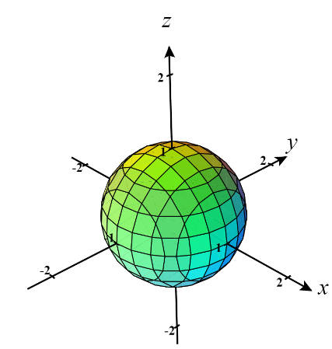
We seek Note that is the boundary of the simple solid region of and F has partials which are continuous everywhere.

So, the Divergence Theorem tells us:

where we have used the well-known formula for the volume of a sphere for the last equality.

Note: This result agrees with what we found in Example 1 from section 5.6!

Example 4: Suppose that is the surface given by that exists below . Kyle tries to find the flux of across with respect to downward normals by using the Divergence Theorem but his teacher tells him that he can’t do this. Why doesn’t the Divergence Theorem apply here?

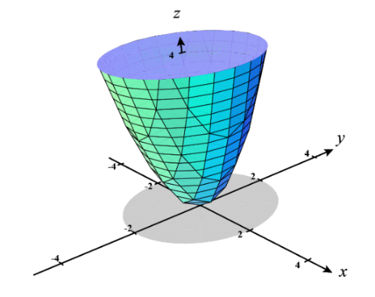
The Divergence Theorem doesn’t apply here because is NOT a closed surface!
Therefore, the conditions to use the Divergence Theorem are not met.

Example 5: Suppose that is the surface that bounds the region enclosed by and . Find the flux of across with respect to outward normals.


Note that is the boundary of the simple solid region of
and the partials of F are continuous everywhere.

So, the Divergence Theorem tells us:
We then attempt to bound the region to set up the triple integral. We see that
.
We then project G into the xy-plane and get the region .
Therefore,

Note: This result agrees with what we found in Example 5 from section 5.6!

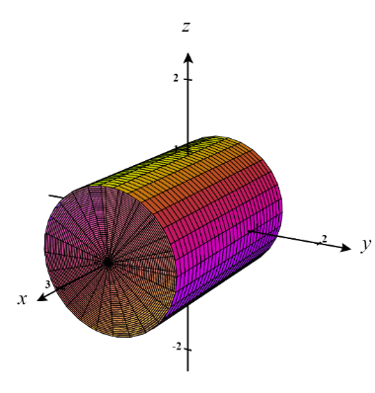
Example 6: Find the flux of F across where and is the surface with outward orientation shown below that bounds a solid region G using the cylinder and the planes and .

- Complete this question by using the Divergence Theorem.

We seek . Note that is the boundary of the solid region of and the partials of F are clearly all continuous everywhere. So, the Divergence Theorem tells us:
To find the rightmost triple integral, we must employ the techniques of chapter 4. Since we are dealing with a right circular cylinder it makes sense to use cylindrical coordinates where the x-axis plays the role of the z-axis.

Clearly, the most restrictive inequalities on x are , and the projection of G onto the yz-plane is the unit circle. So, we have that
- Setup, but do not evaluate, integrals which represent this flux by computing the flux directly.

We note that we have 3 separate flux integrals to calculate. One for each of the two circles and another for the cylinder.

Let , where (circle at )
Let , where (circle at )
Let , where (cylinder)

We see that for both circles we get
For the cylinder we get
For we select (since we need normal vectors that point outward…meaning down the negative x-axis).
For we select (since we need normal vectors that point outward…meaning down the positive x-axis).
For we select (since we need normal vectors that point outward from the cylinder. You can check the direction of when and compare this to the points on the surface that this value to see that the vector given by would be facing the wrong direction here.)

Therefore, the flux through each surface is

So, the total flux is given by

Fact: The Divergence Theorem also holds for regions that are the finite union of simple solid regions.

Note: Proving this fact is similar to proving that Green’s Theorem holds for regions with holes.

Example 7: Suppose the surface is made up of two separate surfaces represent a unit cube and unit sphere (as shown in the image below). Show how the Divergence Theorem can be used to find the flux of across with positive orientation.
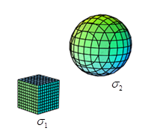
We see that since and so .
By the above fact since both are closed surfaces and F has partials which are continuous everywhere then we can say that

